Attention Supervisors, Assistant Directors and Directors
you are invited to an upcoming Workshop & Director’s Meeting

Indigenous Worldview for Early Childhood Education and Visitors, Protocol and Sharing Gifts

presented by Rebecca LaRiviere

A member of the Metis Nation and resides in Treaty 1 Territory. She is a mother, an ECE III, a professional speaker, and an instructor at RRC Polytech. She has spent much of her career learning from and working with Indigenous caregivers on and off reserve by providing training and professional development. She seeks to bridge Indigenous worldview and traditional childrearing practices with contemporary child development research.
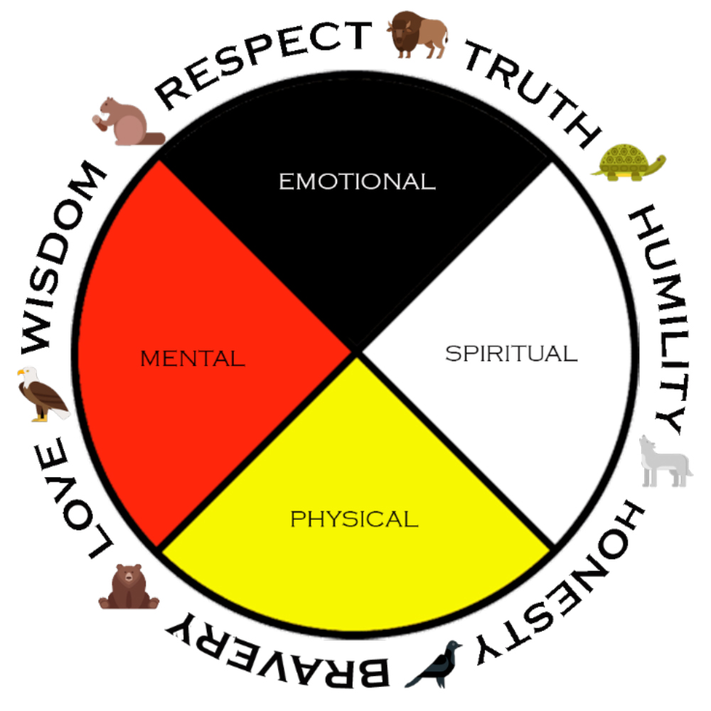

Where: Carman United Church, 142 1st St. Carman, MB

When: Thursday May 16, 2024

Registration/Coffee/Water: 9:00 – 9:30 a.m.

Workshop: 9:30 – 12:30 p.m.

Lunch: 12:30 until 1:15 p.m.

Director Meetings: 1:15 until 2:45 p.m.

Workshops:
Indigenous Worldview for Early Childhood Education
Currently our field has the momentum to determine how to incorporate Indigenous teachings into our programs. How do centers approach this in a good way? This workshop begins with an introduction to Indigegogy, the Medicine Wheel, and gain some perspective in order to provide the context required to make policy, guidance and curriculum decisions that are culturally inclusive.

Visitors, Protocol, and Sharing Gifts
What can centres to do continue to build connections with Indigenous communities in a sustainable way? Learn about the tradition of visiting and knowledge sharing and gain the tools required to continue inviting Indigenous experts, knowledge keepers, or Elders into your programs

